**Class Diagram**

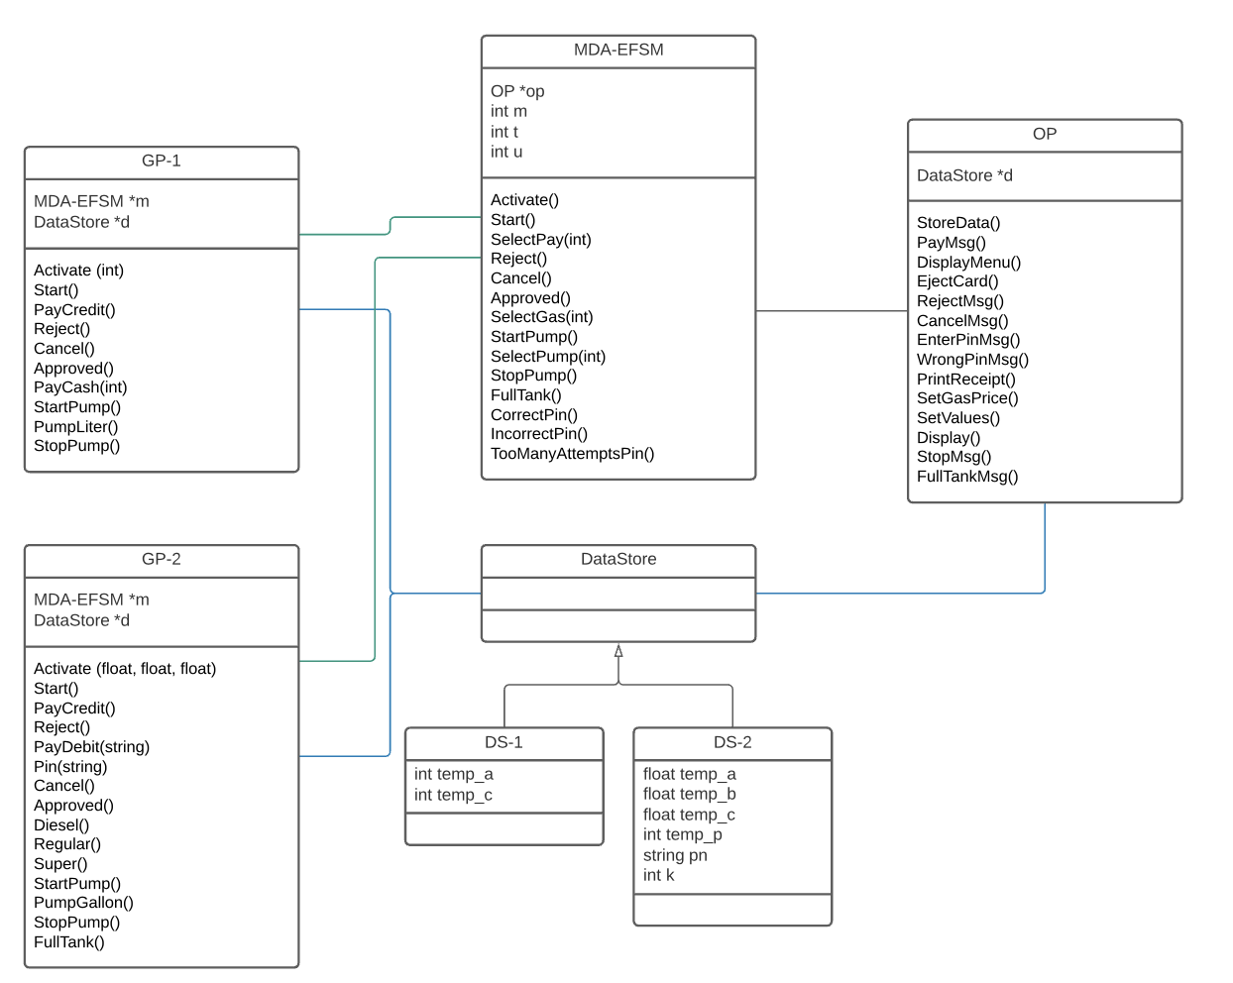

**Note:  
 *MDA-EFSM*** m 🡪 payment method  
 t 🡪 gas type  
 u 🡪 gas unit  
 ***DS-1***  
 temp_a 🡪 gas pump price  
 temp_c 🡪 amount of cash placed  
 ***DS-2***

pn 🡪 pin  
 k 🡪 number of attempts  
 temp_a, temp_b, temp_c 🡪 temporary holders for diff. gas types (diesel, regular, super)

temp_p 🡪 temporary holder for pin (in payment phase)

**State diagram**

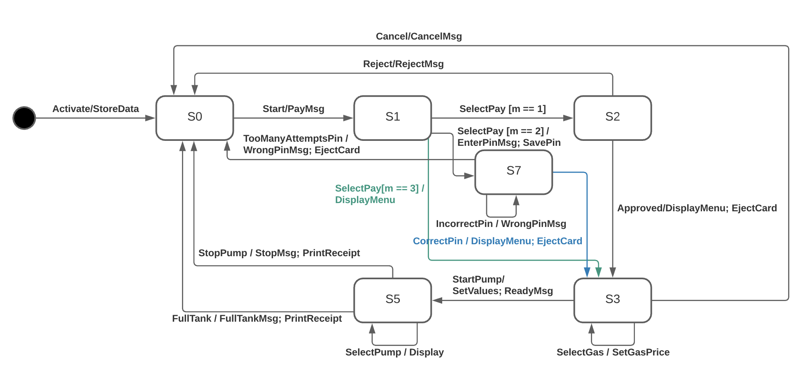

**MDA-EFSM Events**

Activate()

Start()

SelectPay(int m) // m = 1 (**credit**), m = 2 (**debit**), m = 3 (**cash**)

Reject()

Cancel()

Approved()

SelectGas(int t) // t = 1 (**diesel**), t = 2 (**regular**), t = 3 (**super**)

StartPump()

SelectPump(int u) // u = 1 (**liter**), u = 2 **(gallon)**

StopPump()

FullTank()

CorrectPin()

IncorrectPin()

TooManyAttemptsPin()

**MDA-EFSM Actions**

StoreData // store prices for different gas types

DisplayMenu // display a menu with a list of transactions

EjectCard // ejects the card

PrintReceipt // prints a receipt

SetGasPrice // set price for the selected gas type

SetValues // set **G/L** (gas unit) and **total** (gas unit * price)

PayMsg // displays a message regarding payment method

RejectMsg // displays a message when the card was not approved

CancelMsg // displays a message when the user cancels transaction

EnterPinMsg // displays a message when entering a pin

WrongPinMsg // displays a message when user inputs incorrect pin

Display // displays a message of the amount of gas disposed

StopMsg // displays a message when the user stops pumping

FullTankMsg // displays a message after filling the tank full

**Operations of the Input Processor**

**(GP-1)**

Activate(int a) {

d->temp_a = a;

m->Activate();

}

Start() { m->Start(); }

PayCredit() { m->SelectPay(1); }

Reject() { m->Reject(); }

Cancel() { m->Cancel(); }

Approved() { m->Approved(); }

PayCash(int c) {

d->temp_c = c;

m->SelectPay(3)

}

StartPump() {

m->StartPump;

}

PumpLiter() {

m->SelectPump(1);

}

StopPump() {

m->StopPump();

}

**Operations of the Input Processor**

**(GP-2)**

Activate (float a, float b, float c) {

d->temp_a = a;

d->temp_b = b;

d->temp_c = c;

m->Activate();

}

Start() { m->Start(); }

PayCredit() { m->SelectPay(1); }

Reject() { m->Reject(); }

PayDebit(string p) {

d->temp_p = p;

m->PayDebit();

}

Pin(string x) {

if(d->pn == x):

m->CorrectPin();

else if(d->pn != x && d->k <= 1)

m->IncorrectPin();

else if(d->pn != x && d->k > 1)

m->TooManyAttemptsPin();

}

Cancel() { m->Cancel(); }

Approved() { m->Approved(); }

Diesel() { m->SelectGas(1); }

Regular() { m->SelectGas(2); }

Super() { m->SelectGas(3); }

StartPump() { m->StartPump; }

PumpGallon() { m->SelectPump(2); }

StopPump() { m->StopPump(); }

FullTank() { m->FullTank(); }